1. **VTC:**

**1.1. About VTC TELECOMMUNICATIONS JSC:**

VTC Telecommunications JSC (vtctelecom) is a subordinate organization of Vietnam Posts and Telecommunications Group (VNPT). After more than 20 years of establishment, construction, and development, VTC Telecommunications JSC is proud to contribute effort to the construction and development of the largest telecommunications network in Vietnam: VNPT’s telecommunications network. The company has experienced engineers and full facilities.

**1.2. Financial series(Total assets):**

This part analysis about the VTC TELECOMMUNICATIONS JSC total assets from the first quarter of 2009 to the fourth quarter of 2022 ( 52 observations).

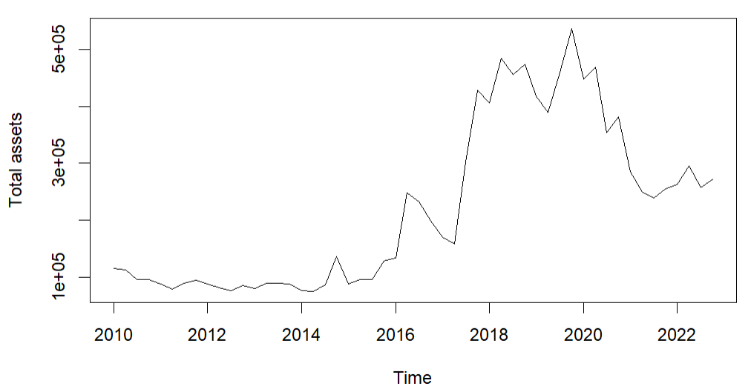

***Figure 1:*** *Total assets of VTC*

Figure 1 is an overview graph of the total assets from the first quarter of 2010 to the fourth quarter of the year 2022.

There are 8 different models used for forecasting total assets of quarters in 2023:

| Model | Quarter | 2023 Forecast | RMSE, MAPE for whole data | | RMSE, MAPE for 4 last observations | |
| --- | --- | --- | --- | --- | --- | --- |
| MAPE | RMSE | MAPE | RMSE |
| [1] Time Trend Regression (Linear-Linear) | 1st | 409087.6 | 42.94% | 97508.55 | 30.51% | 120735.23 |
| 2nd | 416185.9 |
| 3rd | 423284.2 |
| 4th | 430382.5 |
| [2] Time Trend Regression (Log-Linear) | 1st | 476870.4 | 34.42% | 108937 | 37.42% | 165031.35 |
| 2nd | 494845.1 |
| 3rd | 513497.3 |
| 4th | 532852.5 |
| [3] Linear Trend + Seasonality (Additive form) $Y_{t}=27718.2+7071.4t+5923.9*s_{2t}+\left(-802.1\right)*s_{3t}+18360.7*s_{4t}$ | 1st | 402502.4 | 43.07% | 97207.67 | 30.36% | 120357.57 |
| 2nd | 415497.7 |
| 3rd | 415843.1 |
| 4th | 442077.3 |
| [4] Linear Trend +Seasonality (Additive and Multiplicative form) $Y_{t}=31003.9+6940*t+\left(-2143.9\right)*s_{2t}+5525.3*s_{3t}+6576.1*s_{4t}+315.4*t*s_{2t}+(-224.6)*t*s_{3t}+435*t*s_{4t}$ | 1st | 398823.9 | 42.87% | 97129.86 | 30.34% | 120460.88 |
| 2nd | 420651.6 |
| 3rd | 405876.2 |
| 4th | 450580 |
| [5] Log-Linear Trend +Seasonality (Additive form) $lnln \left(Y_{t}\right) =11.096+0.036t+0.013s_{2t}+\left(-0.004\right)s_{3t}+0.074s_{4t}$ | 1st | 444186.6 | 34.16% | 108770.6 | 34.29% | 146903.96 |
| 2nd | 466493.8 |
| 3rd | 475441.9 |
| 4th | 532852.5 |
| [6] Log-Linear Trend +Seasonality (Additive and Multiplicative form) $lnln \left(Y_{t}\right) =11.108+0.036t+\left(-0.022\right)*s_{2t}+\left(-0.012\right)*s_{3t}+0.068*s_{4t}+0.0014*t*s_{2t}+0.0003*t*s_{3t}+0.0002*t*s_{4t}$ | 1st | 449548.9 | 34.11% | 108714.5 | 35.88% | 156175.38 |
| 2nd | 491688.2 |
| 3rd | 485289.1 |
| 4th | 542096.9 |
| [7] Holt-Winters (Additive form) $Y_{t+k}=\left(253246.502+\left(-2764.345\right)k\right)+s_{coresponds}$ | 1st | 243067 | 13.56% | 48460.24 | 3.67% | 14829.31 |
| 2nd | 252518 |
| 3rd | 245725.4 |
| 4th | 261293.6 |
| [8] Holt-Winters (Multiplicative form) $Y_{t+k}=\left(247152.9+\left(-2149.798\right)k\right)*s_{coresponds}$ | 1st | 243043.1 | 13.28% | 46183.21 | 5.68% | 20771.74 |
| 2nd | 244553.3 |
| 3rd | 239500 |
| 4th | 262886.2 |

***Table 1.*** *Result analysis VTC total assets*

The above models are forecasted with training sets from 2010 to 2021. We can see that the smallest MAPE (2022) falls into the Holt-winter additive model with MAPE = 3.67%; The smallest overall MAPE falls in the Holt-winter multiplicative model with MAPE = 13.28% and in the Holt-winter add MAPE model the overall MAPE is 13.56%. Therefore, these are the two best forecasting models for 2023.

**1.3. Stock Price VTC forecasting using ARIMA:**

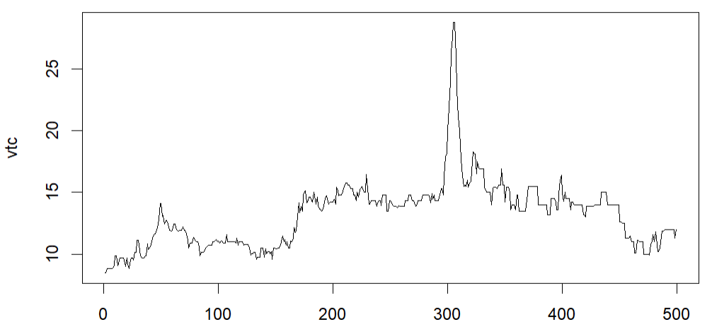

***Figure 2:*** *Line graph of stock price VTC*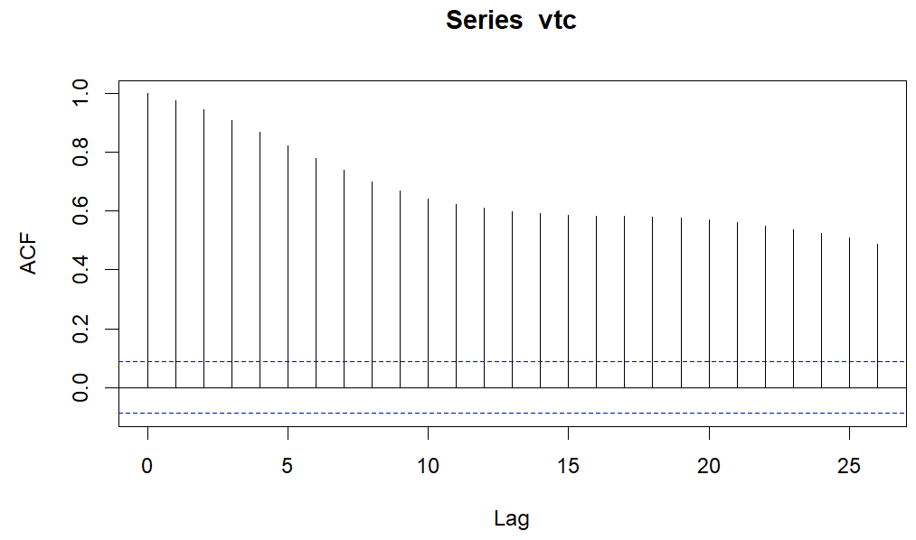

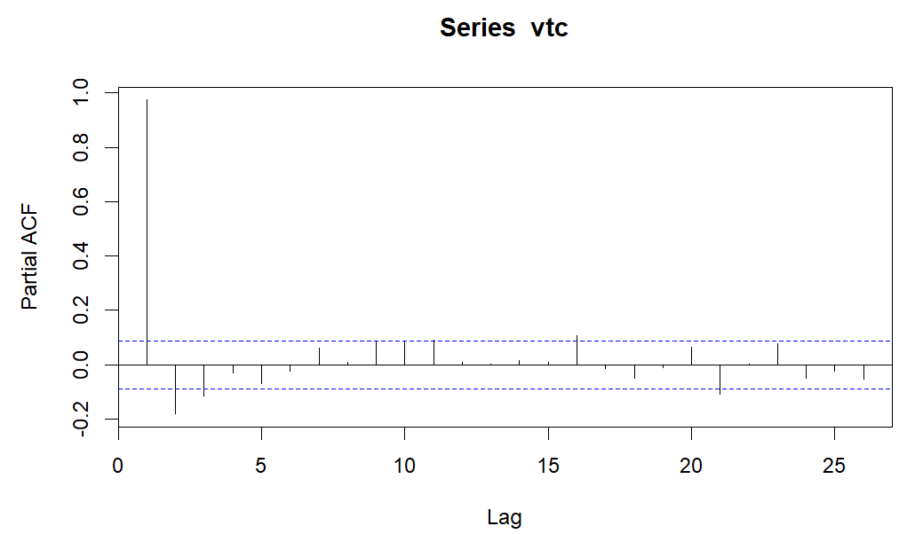

***Figure 3:*** *PACF, ACF of VTC stock price in 2021-2022*

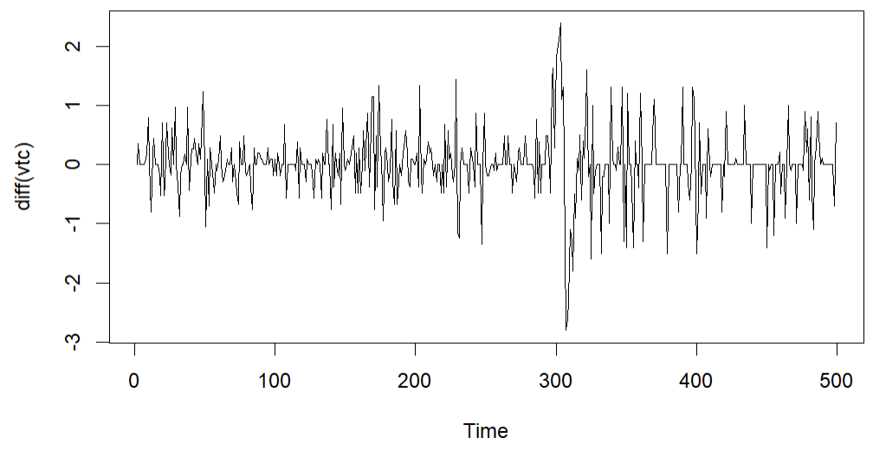

***Figure 4:*** *1st Order Differencing*

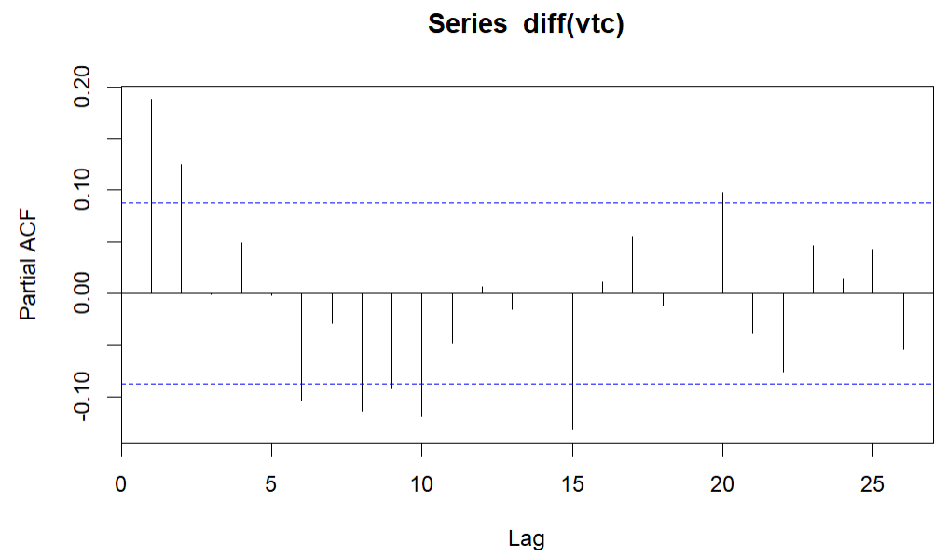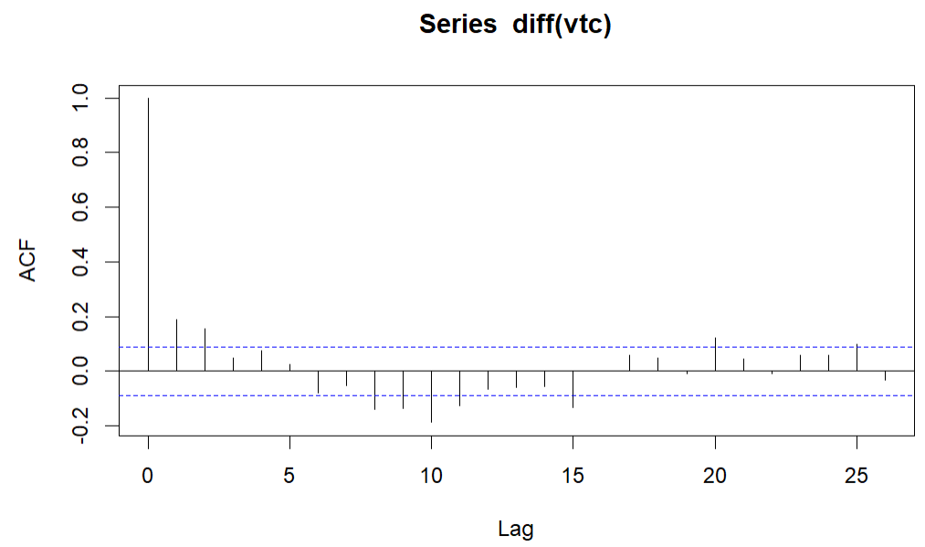

***Figure 5:*** *PACF, ACF of difference series*

According to ACF and PACF choose the best model. So I used AIC to find the best model, and the result is ARIMA (1,1,9) is the best model with the smallest AIC = 809.79.

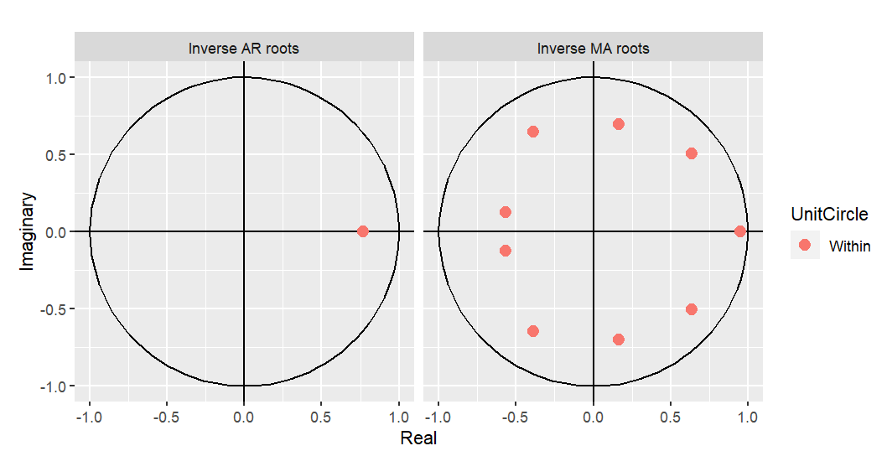

***Figure 6:*** *Inverse roots of ARIMA(1,1,9)*

With model ARIMA(1,1,9) we use Ljung-Box test for check for the residuals of the model. And the result is no serial correlation with P-value = 0.3475.

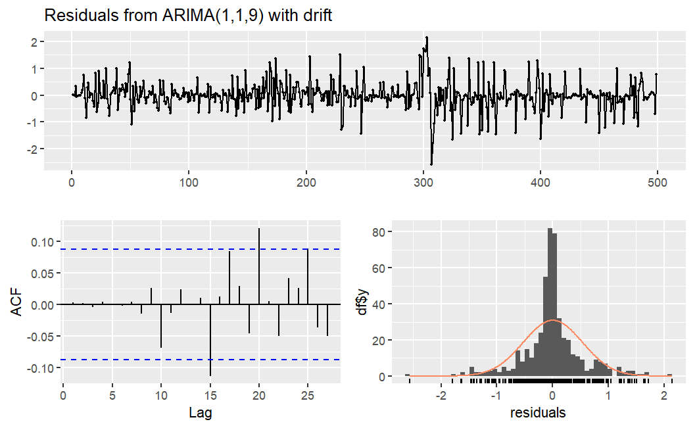

***Figure 7:*** *Residuals check for ARIMA(1,1,9)*

The result of forecasting for the first 10 observations in 2023:

| No. | Forecast  price | Actual price | With RMSE and MAPE with results of 0.532 and 2.54% respectively, and MAPE of the next 10 values forecast is 1.99%. The ARIMA model (1,1,9) can be used for forecasting. |
| --- | --- | --- | --- |
| 1 | 12.04 | 12 |
| 2 | 12.13 | 12 |
| 3 | 12.10 | 12 |
| 4 | 12.12 | 12 |
| 5 | 12.17 | 11.8 |
| 6 | 12.12 | 11.8 |
| 7 | 12.14 | 11.8 |
| 8 | 12.15 | 11.8 |
| 9 | 12.11 | 11.8 |
| 10 | 12.08 | 11.8 |